1)What is Bayes' theorem?

Ans- Bayes' Theorem states that the conditional probability of an event, based on the occurrence of another event, is equal to the likelihood of the second event given the first event multiplied by the probability of the first event.

2) What is the formula for Bayes' theorem?

Ans-

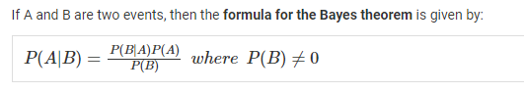

3) How is Bayes' theorem used in practice?

Ans- Bayes' Theorem thus gives the probability of an event based on new information that is, or may be, related to that event. The formula can also be used to determine how the probability of an event occurring may be affected by hypothetical new information, supposing the new information will turn out to be true.

4) What is the relationship between Bayes' theorem and conditional probability?

Ans- Bayes' Theorem states that the conditional probability of an event, based on the occurrence of another event, is equal to the likelihood of the second event given the first event multiplied by the probability of the first event.

5) How do you choose which type of Naive Bayes classifier to use for any given problem?

Ans- Naïve Bayes Classifier Algorithm. Naïve Bayes algorithm is a supervised learning algorithm, which is based on Bayes theorem and used for solving classification problems. It is mainly used in text classification that includes a high-dimensional training dataset.

6) Assignment:

You have a dataset with two features, X1 and X2, and two possible classes, A and B. You want to use Naive

Bayes to classify a new instance with features X1 = 3 and X2 = 4. The following table shows the frequency of

each feature value for each class:

Class X1=1 X1=2 X1=3 X2=1 X2=2 X2=3 X2=4

A 3 3 4 4 3 3 3

B 2 2 1 2 2 2 3

Assuming equal prior probabilities for each class, which class would Naive Bayes predict the new instance

to belong to?